***Lab # 05***

***Working with Custom Functions in C***

**Software Tools:**

• CodeBlocksIDE or similar

**Pre Lab Reading:**

**Functions in C:**

A function gives a name to a parameterized computation—it is the implementation in code of a specific algorithm. All of the code that you will read or write (in this book) will be inside of functions. There are two sides to using functions in your programming: declaring a function— which provides the definition for how a function behaves—and calling a function—which executes the definition of the function on specific values of the parameters.

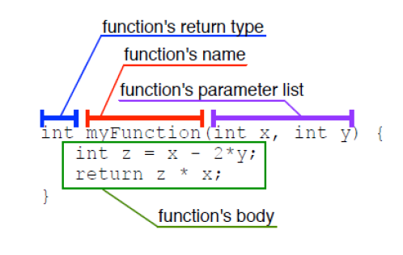

**In-Lab Task 1:**

Write a C function 'int test_prime(int);' that takes in a positive number as input and returns true (1) if the input number is prime or false (0) if the input is not prime. Then using this function, write a C program that takes a number (N) as input from the user and prints out the first N prime numbers.

**Program:**

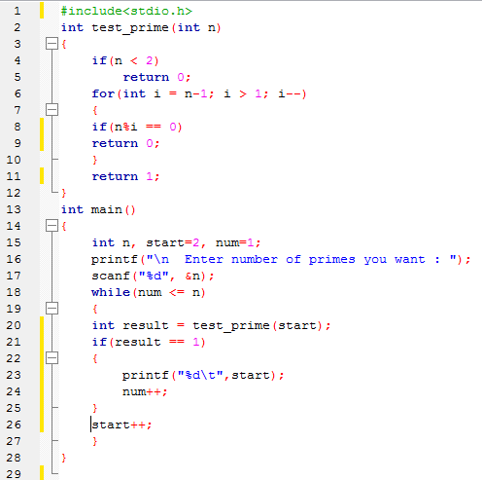

**Output:**

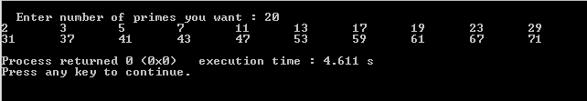

**In-Lab Task 2:**

1. Write a C program that asks user to input a value for 𝜃 in degrees .It should then calculate the value of the mathematical function 𝐲 and print its value on screen. Write separate functions to implement 𝑓1(𝜃) 𝑎𝑛𝑑 𝑓2(𝜃) .

**Hint**: include the ‘**math.h**’ library and use the following functions. Remember that these functions expect inputs to be in ***Radians***.

**double sin(double x);**

**double cos(double x);**

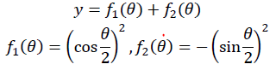

**Program:**

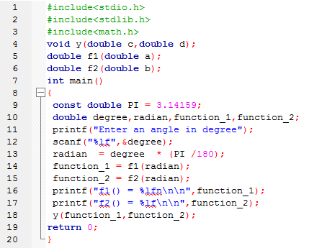

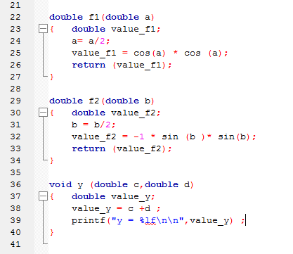

**Output:**

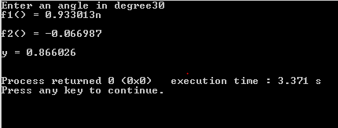

**(b)** Modify the above program to calculate the value of 𝑦.

**Hint**: include the ‘**math.h**’ library and use the following function:

**double sqrt(double x);**

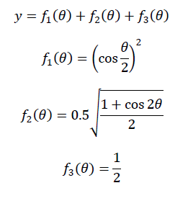

**Program:**

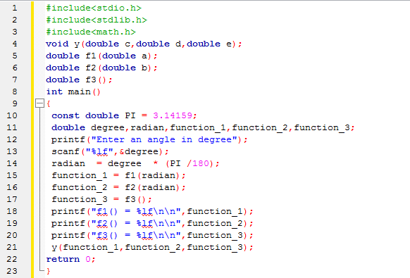

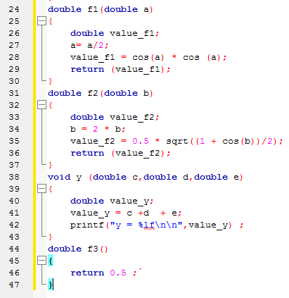

**Output:**

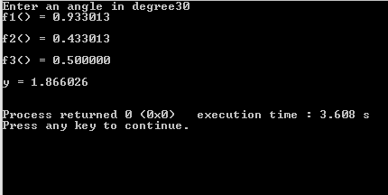

**Post Lab Task:**

Write a C program that takes two floating type inputs from the user and calculates their average, individual factorials, and a function 𝑓(𝑥,𝑦)=√𝑥2+𝑦2. Use separate C functions to compute the average, factorial and the function ‘f’. The program should print the results in the **main** function.

**Program:**

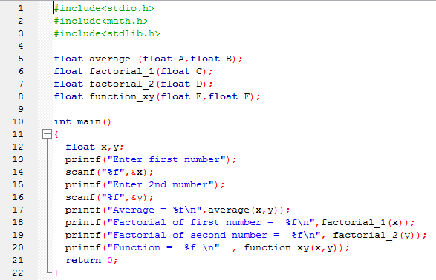

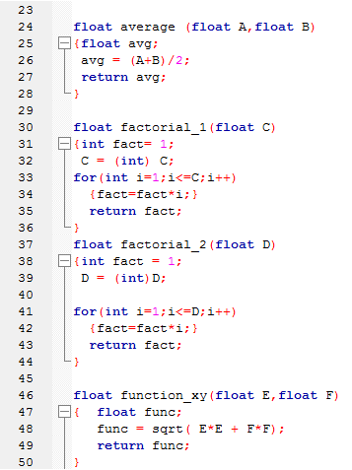

**Output:**

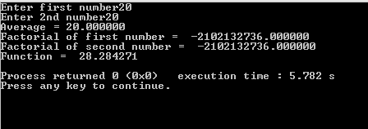

**Critical analysis:**

In in lab, we learn about the basic concept of functions in c language and how to use custom functions in C. We implement mathematical functions in programs using C functions. Math.h library is used to add mathematical operations in program.